**TITLE PAGE**

**Article title**

Wear particles’ auto-classification using deep convolutional neural network with transfer learning

**Author Details**

Liu Hong

[Lab of oil analysis, ShangHai Maritime University,1550 LinGang Avenue,Shanghai , People's Republic of China] Email: [saoliuhong@126.com](mailto:saoliuhong@126.com)

Wei Haijun

[Lab of oil analysis, ShangHai Maritime University,1550 LinGang Avenue,Shanghai, People's Republic of China] Email: [Haijun_welson@163.com](mailto:Haijun_welson@163.com)

Wei Lidui

[Lab of oil analysis, ShangHai Maritime University,1550 LinGang Avenue,Shanghai, People's Republic of China] Email: [weilidui@163.com](mailto:weilidui@163.com)

LI Jingming

[Lab of oil analysis, ShangHai Maritime University,1550 LinGang Avenue,Shanghai, People's Republic of China] Email: [jmli@shmtu.edu](mailto:jmli@shmtu.edu)

An Chao

[Lab of oil analysis, ShangHai Maritime University,1550 LinGang Avenue,Shanghai, People's Republic of China] Email: An_chao1994@163.com

**Corresponding author: [Wei Haijun]**

**[Haijun_welson@163.com]**

**Acknowledgments:**

The financial support of the present research was provided by natural science fund projects of Science and technology commission of shanghai municipality (Grant no.17ZR1412700).

**Abstract:**

**Purpose:** Wear particles contained in lubricating oil carries valuable information about the condition of the machine. Conventional off-line wear particles’ analysis is expensive and expert oriented. To develop an on-line monitoring system for condition based maintenance and fault diagnose, auto-classification of wear particles is required.

**Methodology:** In this study, deep convolutional neural network is used for identification of five kinds of wear particles, including severe sliding particle, fatigue laminar particle and chunky type particle which are considered very difficult to distinguish. Wear particles’ dataset is built by various kinds of tribo-tests. A pseudo-on-line ferrograph is designed for particle collection. The effectiveness of three representative models under different transfer learning cases is studied.

**Conclusion:** Deep neural network with proper setting shows promising result. It offers high accuracy and with proper computing complexity. A conclusion can be drawn that the proposed method is suited for wear particles’ identification and can be put into practical use in condition monitoring systems in the future.

**Keywords:** wear particle classification, on-line ferrography, condition monitoring, deep convolutional neural network, transfer learning

Wear particles’ auto-classification using deep convolutional neural network with transfer learning

**Abstract:**

Wear particles contained in lubricating oil carries valuable information about the condition of the machine. Conventional off-line wear particles’ analysis is expensive and expert oriented. To develop an on-line monitoring system for condition based maintenance and fault diagnose, auto-classification of wear particles is required. In this study, deep convolutional neural network is used for identification of five kinds of wear particles, including severe sliding particle, fatigue laminar particle and chunky type particle which are considered very difficult to distinguish. Wear particles’ dataset is built by various kinds of tribological tests. A pseudo-on-line ferrograph is designed for particle collection. The effectiveness of three representative models under different transfer learning cases is studied. Deep neural network with proper setting shows promising result. It offers high accuracy and with proper computing complexity. A conclusion can be drawn that the proposed method is suited for wear particles’ identification and can be put into practical use in condition monitoring systems in the future.

**Keywords:** wear particle classification, on-line ferrography, condition monitoring, deep convolutional neural network, transfer learning

## Introduction

One big trend in mechanical equipment’s maintenance is condition monitoring. The idea is using real-time data to determine the equipment’s health and respond only when maintenance is actually necessary [1, 2]. These data are often informative such as sound, vibration or temperature, and among them particularly, there are wear particles. Wear particles are generated as components move relative to each other. The parameters that define wear particles such as their shape, size, surface texture, etc. reflect the wear modes, wear mechanisms, and the severity associated with their generation [3, 4]. As a non-destructive testing technology, wear particle analysis can, on the one hand, prolong the oil change intervals and reduce unnecessary regular maintenance, on the other hand, it can predict potential failures from early stage to avoid catastrophic accidents [5, 6]. The availability of modern instrumentation provides a wide array of studies that helped identify the characteristics of wear particles and the mechanisms by which they generated. Approaches by observing and analyzing wear particles are thus promising solution of condition based maintenance [7, 8].

Ferrography uses a high-gradient magnetic field to extract wear particles from a fluid sample as it flows down a specially prepared microscope substrate [9]. The schematic of ferrography is demonstrated in fig.1. The problem with current off-line ferrography techniques is that the particle morphology assessment, particle classification and the machine status evaluation relies heavily on human expertise, which is time-consuming, costly and objective. These limitations have driven further development and need to automate the technique. The automation of wear particles' classification is the cornerstone for on-line wear particles analysis which will certainly benefit the industry and reduce the need for manpower [10, 11].

In recent years, researchers made considerable efforts to build auto-classification system for wear particles. It is reported that various machine learning algorithm can be used to identify wear particles [12, 13, 14]. Peng.Z et al used the cluster analysis in the gray system theory for the identification of wear particles [15, 16]. Also, in the study by Stachowiak and Podsiadlo [17, 18, 19], attempt had been made to distinguish adhesive, fatigue and abrasive particles using area, perimeter and elongation parameters, these studies showed that these simple parameters are effective for certain types of wear particles such as abrasive particles and sphere like fatigue particles. In these studies, the pictures of particles were taken by scanning electron microscopes. Scanning electron microscopes can take high-quality photos, however, the preparation and shooting conditions (spray gold, vacuum environment) of models have severely limited the possibility of on-line detection. Wu Tonghai team carried out extensive research on the on-line monitoring of wear particles [20]. The team had independently developed a set of online visualized ferrography and proposed that the area of particle coverage and particle diameter in the visible area can be used as indicators for judging the status of the machine. This study provides a hardware design for on-line ferrography. However, because the surface texture of the particles is not obtained, the wear mode cannot be accurately reflected. To sum up, a lot of research had been done on the classification of wear particles. The recognition of cutting, spherical and oxide abrasive grains has basically been realized while classification of similar particles such as severe sliding particles, laminar particles, and fatigue chunky particles is not entirely successful yet.

Deep neural networks (DNNs), also referred to as deep learning, are a sub-field of machine learning which aims at giving computers the ability to learn without being explicitly programmed. DNNs are currently widely used for many artificial intelligence applications including computer vision, speech recognition, and robotics [21, 22]. For image recognition problems, the main models used are convolutional neural networks (CNNs). The local connections, weight sharing and pooling operations of CNNs effectively reduce the complexity of the network and therefore reduce the number of training parameters. Also the model has some degree of invariance to translation, distortion, and scaling. Krizhevsky et al. [23] used the CNN with extended depth to obtain the best classification accuracy at the ImageNet Large Scale Visual Recognition Challenge (LSVRC) in 2012. Since then, CNN models have been dominated in all kinds of image recognition competitions. DNNs have broad prospects for wear particle’s auto classification, yet relevant research is nearly blank so far.

The objective of this study is to build a deep convolutional neural network for wear particles’ identification from scratch, solving practical problems such as generating different kinds of wear particles, DNNs’ model selection and transfer learning testing. Using this network to complete the task of accurately identifying fatigued chunky particles, laminar particles, severe sliding particles, and provide technical support for the on-line application of ferrography.

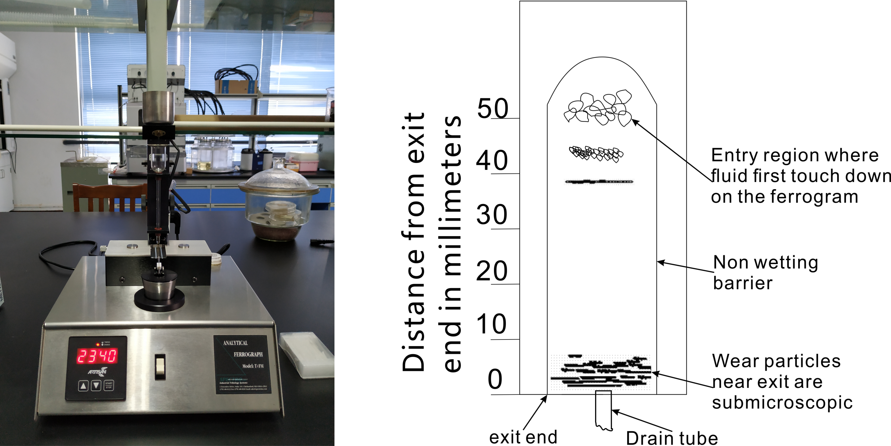

Figure 1 Analytical ferrogram and schematic diagram.

## METHODOLOGY

### 2.1 Data collection

***2.1.1 Pipe line of deep learning***

In this research, we focused on classification of five wear particles: normal rubbing particles, severe sliding particles, cutting wear particles, laminar fatigue particles and chunky particles [13, 24]. Each image sample is assigned to one of these labels accordingly. Since it's a classification task, the pipeline can be formalized as follows:

**Input:** The input consists of a set of labeled images. These data are referred to as the training set. In detail, these images are represented by an array of pixels of the same size.

**Learning:** The process is to use the training set to learn what every one of the classes looks like. Specifically, through back-propagation and gradient decent algorithms, parameters (weights and bias) in the neural network adjust so that the final loss function is minimized. The loss function itself is a measurement of distance between prediction and ground truth. The step is also called training.

**Evaluation:** In this step, a new set of images is given to the model finished training. The output label is compared to the ground truth label. The accuracy of prediction is used to evaluate the model.

***2.1.2 Generation of wear particles***

The Bruker’s UMT Universal Mechanical Tester has been used in experiment to generate different kinds of wear particles. The machine, showed in fig.2, has a universal base that can be equipped with a range of drive modules simulating rotational, linear, or oscillating motions as well as an upper carriage fitted with a force measuring sensor. Three kinds of tribology tests have been performed to simulating different wear mode: Pin on disk test, pin on plate test and 4-ball test.

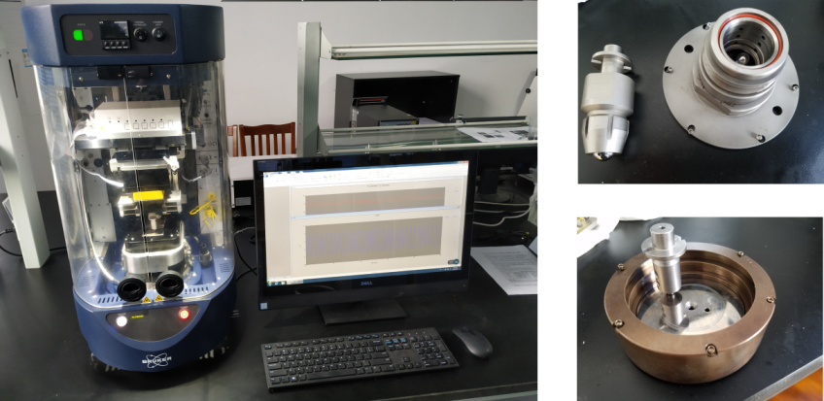

(a)Bruker UMT’s base (b)four ball moduel and pin on disk module

Figure 2 Bruker’s UMT universal mechanical tester.

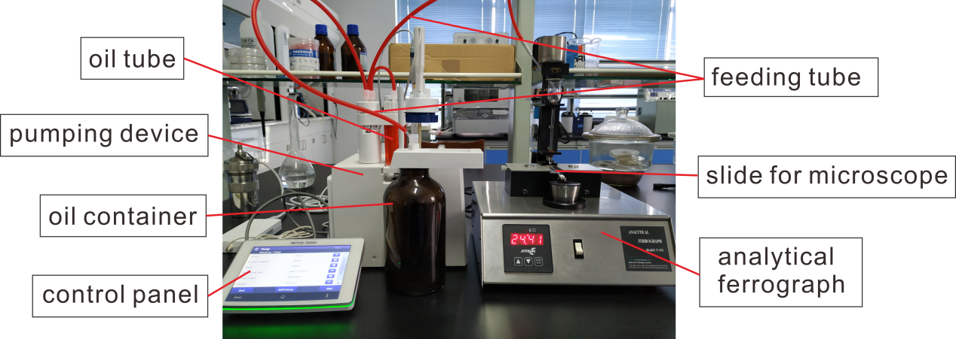

Figure 3 Connection of Analytical ferrogram and lubricating oil cycling system.

Pin on disk consists of a stationary pin loaded against a rotating disk. (The tests were conducted in a laboratory air with temperature of 22℃ and a relative humidity of 50%). The upper pin made of standard 416 stainless steel were cylindrical in shape with polished flat ends of 8*mm*, The disk is made of alloy steel E52100 with surface roughness RA=0.02*μm*. The Mobile Gard 412 had been used as lubricant. The tests were conducted at 900r/m, which means the linear velocity reached 170mm per second. The wear particles were generated under condition of a 30kg (294N) load for 25h. Pin on disk test is mainly for generating adhesive wear particles. Adhesive wear is the transfer of material from one contacting surface to another. The tests were set this long so that both mild wear particles and severe particles can be generated. Some pictures of adhesive particles are showed in first row of fig.4(b). They are mostly small particles formed in chains, especially in last two pictures particles stick together due to magnetization which is quite common in ferrograph [25].

Compared to pin on disk test, Pin on plate test replaced the rotating module by a reciprocating module. The upper pin is made of cast iron HT250 and the plate is made of Gr15 steel with surface roughness RA=0.2*μm*. The stroke is set to 18mm and frequency is set to 4Hz. The wear particles were produced with a 48kg (470.4N) load for 12h. Unlike pin on disk test, pin on plate test was mean to simulating the wear condition of reciprocating friction pairs such as piston-ring cylinder or hydraulic cylinder. It can be seen from the pictures in second row of fig.4(b), some of the severe sliding wear particles are quite large with clear surface scratch due to rough surface and long hours of wear process.

The fatigue wear particles were generated by 4-ball testing machine. The material of the ball is GCr15 (hardness 63*HRC*). Maximum load and speed were set to 1500N and 300r/min. In order to generate fatigue wear particles the running time is set to 30h. Fatigue begins with reduced lubrication regime and continuous stresses that exceeded the endurance limit of the material, causing cracks beneath the surface. This creates micro-pitting and eventually destructive spalling. The fatigue particles are demonstrated in the third row of fig.4(b), there are some micro spalling particles in the first two pictures and some chunky laminar particles in last two pictures.

***2.1.2 Sampling and Dataset preprocessing***

To simulate an on-line system, lubricating oil was put in a container connecting to analytical ferrogram by a rubber tube. The oil flow is driven by a small pump as showed in fig.3. Since the Bruker’s UMT can’t attach to the system directly, lubricating oil were extracted after each kind of test and put into the container. The container, pump and tubes serve as a flow system of on-line sampling process. Ideally, there should be an auto-cleaning system to wash off the residuals in the substrate, but in this experiment the cleaning process is done manually.

Images were shot by optical microscopy OlypusBX51 with a Color Charge Couple Device (CCD) Camera as showed in fig.4(a). Most of the pictures were taken under 200× magnification because it produces sharp and clear image of particles of size 50μm to 400μm which are of particular interest in this study. The pictures of different kinds of particles were carefully selected and then cut off from original picture, after attaching them with label, the dataset was ready. In total, more than 2000 pictures had been chosen. The advantage of optical microscopy is that sample preparation is relatively easy and it has the potential to be converted to on-line image capturing. Besides the pictures taken in the experiments described above, part of the images in Wear Particle Atlas were also included in the dataset for diversity.

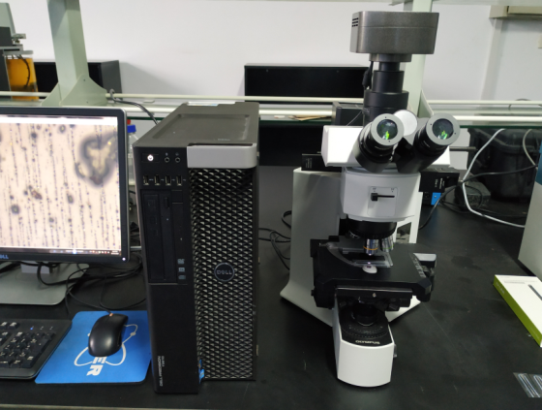 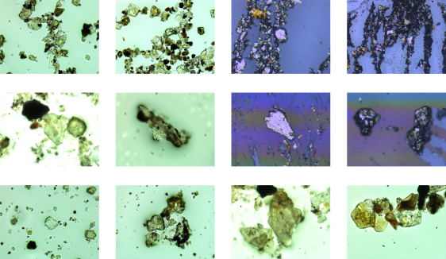

1. optical microscopy with CCD (b) typical wear particles’ images

Figure 4 Examples of wear particles generated in the tests.

In order to evaluate the effectiveness of the model, the dataset is split into training set, validation set and test set. The validation set is used for setting the hyper-parameters of the model such as learning rate from the back-propagation algorithm. Different hyper-parameter values can be tested, the values that lead to the best performance on the validation set is kept. The test set is used for the final evaluation of a model. To prevent overfitting, the rule of thumb is that test set shall never be touched until a single time, at the very end. An example of data splits is showed in fig.5. In this experiment, mean subtraction was applied as preprocessing. It involves subtracting the mean across every individual feature in the data. One crucial thing to note is that mean subtraction must only be done on the training set, and then applied to the validation and test data [23, 26]. For instance, computing the mean and subtracting it from every image across the dataset and then doing the data splitting would be a mistake. To increase the diversity of the dataset, each image fed into the deep learning model is randomly cropped from the original image or its horizontal-flipped version. The idea is to guarantee the network can generalize well in different situations and robust to small image transformations.

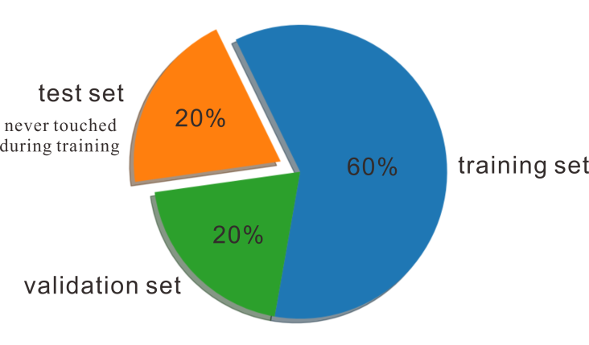

Figure 5 A classic datasplitting strategy.

### 2.2 Deep neural networks architectures

Convolutional Neural Networks is a common form of DNNs for image classification tasks [23]. The networks are composed of multiple CONV layers as shown in fig.6. In such networks, each layer is supposed to generate a successively higher-level abstraction of the input data, called a feature map, which holds important unique information. Nowadays, a deep neural network can contains a thousand CONV layers [27], giving the model extremely representation power. Fully-connected layers serve the purpose of final classification in the end of structure. Non-linearity is referred to a non-linear activation function. Typically it is applied right after CONV or FC layer, the non-linearity is necessary for the model since the network can be simplify to a single linear function mathematically. The most popular non-linearity used is rectified linear unit (ReLU) because of its simplicity [28]. From the demonstration figure one can see that there are also pooling and normalization layers. The definition and effect of these layers is introduced in [29].

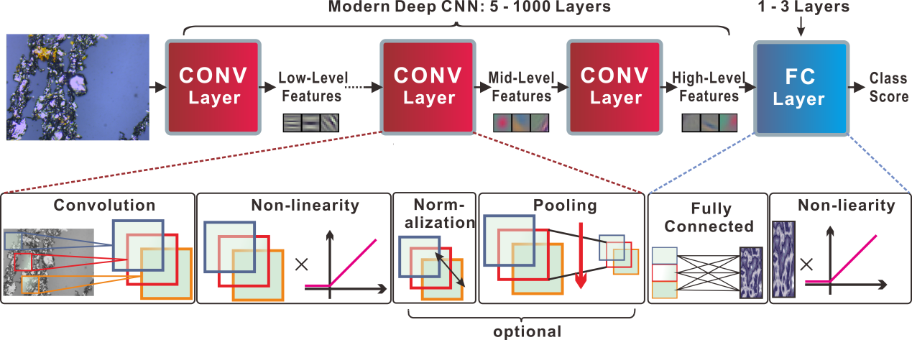

Figure 6 Framework of typical modern deep convolutional neural network.

Various DNN models for image classification have been developed in the past decade. We have tested 3 popular DNN models which have quite different architectures in terms of layer types, layer shapes and the way layers are connected. In this section, the detail of these models is introduced.

***VGG16*** [26]:VGG-16 is a DNN model with 16 layers as it name suggested. The model, consist of 13 CONV layers and 3 FC layers, has a rather plain design. The basic block of the network is CONV layer followed by a Batch Normalization [31] and ReLU as its activation function, this design is pretty standard in current DNN structure. The detail of VGG-16 model is summarized in Table 2 as well as the two models described below.

***GoogLeNet*** [30]:GoogLeNet goes deeper to 22 layers. This model is best known for a unique design: the inception module. As shown in fig.7(a), in the inception module, filters with different receptive field and max-pooling are used in parallel, and their outputs are concatenated for the output of the entire module. The idea is to catch features of multiple scales. The 1×1 filters in the inception module are applied to reduce the number of channels and further lighten the network. This structure is referred to as ‘bottleneck’. The 5×5 CONV layer in the inception module was replaced by two consecutive 3×3 CONV layers, as can be seen from fig.7(b), the receptive field is the same while the number of parameters goes from 25 to 18.These alternations can leads to faster training as well as better generalization [32]. Table1 gives detail information about all the inception modules.

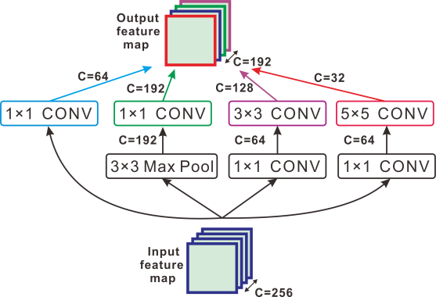

Figure 7 Example of an Inception Module with number of channels.

Note: Each CONV layer is followed by ReLU and BN (not drawn).

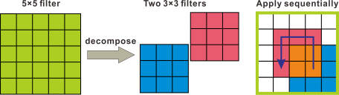

Figure 8 Decomposing larger filters into smaller filters

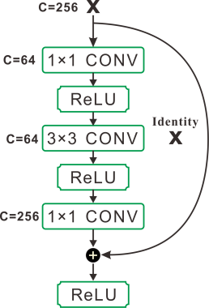 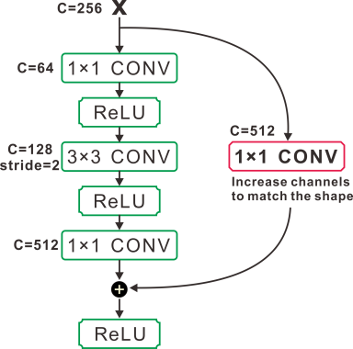

(a) Typical Residual block (b) Residual block that increases dimension

Figure 9 A diagram of Residual connection

***ResNet*** [27]: ResNet goes even deeper to 34 layers or more. In theory, deeper network has greater expressive ability. However, deeper neural network is also more difficult to train, especially with current optimization algorithm which is stochastic gradient decent with back propagation. To address this problem, ResNet proposes a ‘shortcut’ module which contains an identity connection. As demonstrated in fig.9, instead of learning the function for the weight layers *F(x)*, the shortcut module learns the residual function *F(x) = H(x)-x*). This reformulation can help to precondition the mapping. In extreme cases, if the identity mapping was the optimal function, it’s easier for the solver to push the residual to zero than to learn the function as a new one. ResNet family has quite many branches, ResNet-50 was adopted in this experiment in which each stage are composed of a number of residual blocks. The layer information is showed in table2. One thing to note is that in Conv phase2, 3 and 4, the first block increases dimensions as the one showed in fig.9(b). The first 1×1 CONV layer has half the channels and the following 3×3 CONV layer is with stride of 2.

Table1: Number of filters in all inception modules



Table2: Architectures of 3 CNN models. The convolutional layer parameters are denoted as

‘Receptive field , Number of channels’. The ReLU activation function and BN is not shown for brevity.



## Transfer learning implementation

In practice, people seldom train an entire CNN from scratch, because it is relatively rare to have a dataset of sufficient size. What's commonly done is using a CNN which have been trained on a huge dataset such as ImageNet (contains 1000 categories and 1.2 million images) and make use of the information in there. This approach is known as transfer learning, study shows that it’s almost always better to use transfer learning on new dataset [33]. In this study, three transfer learning scenarios were tested:

1. **CNN as a feature extractor**. Replacing the last fully connected layer (fc-1000 in table2) with a classifier for 5 classes since we have 5 different types of wear particles in our dataset. During training, freeze all the learnable parameters in the except the classifier.
2. **Fine-tuning the whole network**. This strategy is to not only replace and retrain the classifier on top of the network on the new dataset, but also to adjust the weights of the pre-trained network.
3. **Fine-tune only Conv phase 3 and 4**, keep earlier layers fixed during training. This is motivated by observation that the features learned by low-level blocks are more general, less abstract than those found higher-up.

In these experiments, hyper parameters were set as follows: For input data, original images were reshaped with its shorter side distributed in [240,320] randomly. As mentioned above, input image of size 224×224 was random cropped from reshaped image or its horizontal flip. For training, stochastic gradient decent with a mini-batch size of 16 and momentum of 0.9 was used. The learning rate was set to ${10}^{-5}$. Both softmax classifier and SVM classifier have been tested, they use cross-entropy loss and multi-classification hinge loss accordingly. For testing, 10-crop testing was adopted [23]. The models were built by Pytorch framework [34] and run on 2 Nvidia GeForce 1080 Titan GPU.

## 4 Results and discussion:

First we took the CNN as feature extractor. The validation-error evolution of the three models (with softmax classifier, same as below) is demonstrated in fig.10. The number of epochs indicates how many times the dataset have been iterated. After each epoch, the model will be tested using the data in validation set, hence the validation error is recorded by epoch. The training error is not shown here for brevity. In fig.10, one can see that the error rate is decreasing, suggesting the learning process is indeed on-going. From the learning curve, one can see that the convergence happens fast, after 20 epochs, the error rate stabilizes at around 25% which is far better than random guess, in this case, 80% (5 categories), yet still unsatisfying. The final test error is given in table 3. Compared to the other two cases, the error rate is relatively high if using the CNNs merely as feature extractor. The reason might be that our dataset of wear particles is not big enough and the morphology features of wear particles are very different from those of categories in ImageNet. Since the dataset is very different, the high-level features already learned is not relevant to the new dataset. Therefore, the classification problem is solely for the fully-connected network to solve which finally leads to poor accuracy.

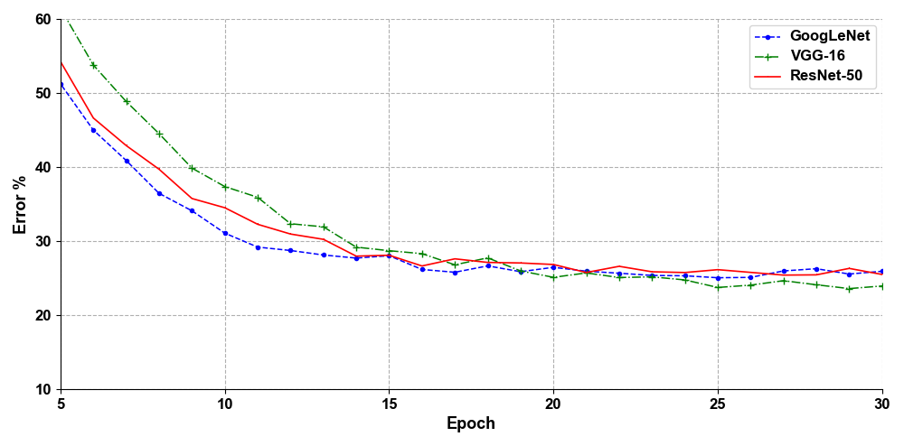

Figure 10 CNNs as feature extractor: validation error during training

Next, all three CNNs were fine-tuned. All the learnable parameters were unfrozen. The learning curve is showed in fig.11. The final validation error is around 5% which is reasonably well for wear particle classification job. From the picture, it is clear that the ResNet-50 learns much faster than the other two networks, reaching 90% accuracy 10-15 epochs a head of GoogLeNet. From table 3, one can see that GoogLeNet performs slightly better than ResNet-50, about 0.15% accuracy. VGG-16 gains nice classification result too (7.56% error rate), yet the learning curve shows that it’s more difficult to train compared to the other two models.

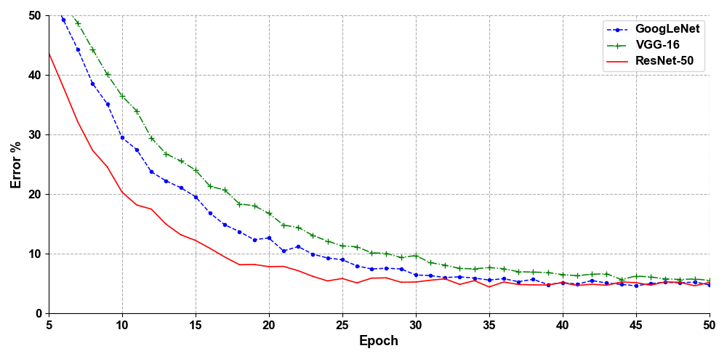

Figure 11 Fine-tune the whole net: validation error during training

Lastly, only CNNs’ weights in phase3 and 4 were fine-tuned. From the learning curve and test result, it’s safe to say that the learning process is similar to the second case. The final test error rate is 7.91% for VGG-16, 5.48% for GoogLeNet and 5.51% for ResNet-50. The use of SVM classifier instead of softmax classifier didn’t show significant difference. Similar to fine-tuning the whole CNNs, ResNet-50’s error rate drops faster than the other two models while VGG-16 is the slowest. GoogLeNet has same level classification accuracy as ResNet-50, slightly better in fact. Since the dataset is relatively small, it is originally believed that fine-tuning the CNNs may lead to overfitting, yet the result shows that no overfitting had happened. We believe it should be attributed to the use of Batch Normalization and proper data augmentation method.

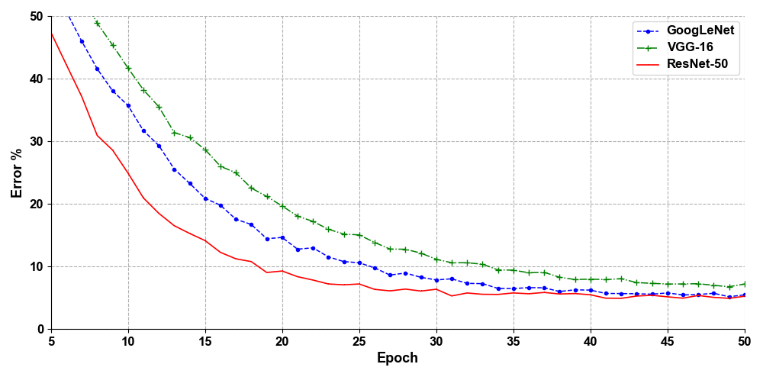

Figure 12 fine-tune only part of the network: validation error during training

Table3: Error rate of test set



Figure.13 gives the total time cost in training of each CNN. From the bar chart we can see that ResNet-50 is more efficient than GoogLeNet and VGG-16 in all three situations, making it a promising architecture for real time training. The reason behind its efficiency is that the residual connections serve as a gradient highway. But with the development of hardware, the time complexity of training small dataset maybe neglected by designer. For instance, fine-tune the whole VGG-16 cost about 50mins which is actually acceptable even if it spend two times longer than ResNet-50.

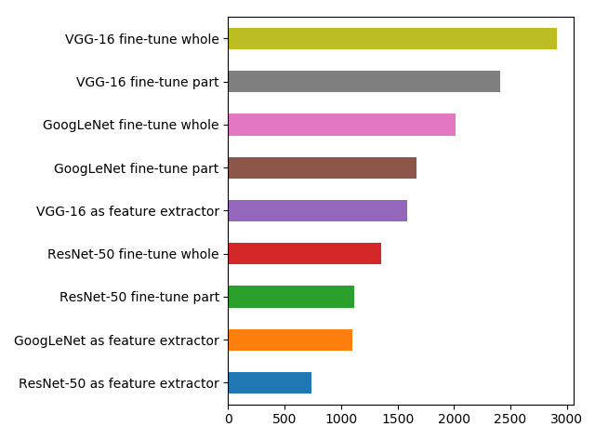

Figure 13 Time cost in training 50 epochs (seconds)

## 5. Conclusion:

Through a series of experiment, not only a deep neural network structure suitable for real-time detection of wear particles can be established, What’s more important is that the training and testing procedure proposed, also a datasets is built which can be valuable for future related research. A conclusion can be drawn that deep convolution neural network is suited for wear particles’ auto classification. Using transfer learning and proper data augmentation methods, VGG-16, GoogLeNet and ResNet-50 all achieve high accuracy. In particular, ResNet-50 with partly fine-tune is proved to be the most efficient way. In further studies, more images of various wear particles should be collected to make a bigger dataset and instance segmentation of wear particles shall draw more attention.

## References:

1. S.K. Yang, A condition-based failure-prediction and processing-scheme for preventive maintenance, IEEE Transactions on Reliability 52 (3) (2003) 373–383. doi:10.1109/TR.2003.816402.
2. S. Raadnui, Wear particle analysis utilization of quantitative computer image analysis: A review, Tribology International 38 (10) (2005) 871–878. doi:10.1016/j.triboint.2005.03.013.
3. W. Li, H. Pham, An inspection-maintenance model for systems with multiple competing processes, IEEE Transactions on Reliability 54 (2) (2005) 318–327. doi:10.1109/TR.2005.847264.
4. Kowandy, C. Richard, M. Chen, Correlation between the tribological behaviour and wear particle morphology case of grey cast iron 250 versus graphite and ptfe, Wear 262 (7-8) (2007) 996–1006. doi:10.1016/j.wear.2006.10.015.
5. R. Upadhyay, Microscopic technique to determine various wear modes of used engine oil, Journal of Microscopy and Ultrastructure 1 (3) (2013) 111 – 114. doi:https://doi.org/10.1016/j.jmau.2013.09.002.
6. S. Ebersbach, Z. Peng, N. Kessissoglou, The investigation of the condition and faults of a spur gearbox using vibration and Wear 260 (1) (2006) 16 – 24. doi:https://doi.org/10.1016/j.wear.2004.12.028.
7. A.K. Jardine, D. Lin, D. Banjevic, A review on machinery diagnostics and prognostics implementing condition-based maintenance Mechanical Systems and Signal Processing20 (7) (2006) 1483 – 1510.
8. N. M. M. Manoj Kumar, Parboti Shankar Mukherjee, Advancement and current status of wear debris analysis for machine condition monitoring: a review, Industrial lubrication and tribology 65 (1) (2013) 3–11.
9. J. Roylance, Ferrography then and now, Tribology International 38 (10) (2005) 857–862.
10. Sperring, T.P.; Nowell, T.J. (2005). "SYCLOPS—a qualitative debris classification system developed for RAF early failure detection centres." Tribology International 38: 898-903.
11. Bartz, W.J. Batchelor, A.W. (2000). Engineering Tribology 2nd edition. Elsevier Butterworth-Heinemann.
12. J. Wang, L. Zhang, The segmentation of wear particles in ferrograph images based on an improved ant colony algorithm, Wear 311 (1-2) (2014) 123–129. doi:10.1016/j.wear.2014.01.004.
13. H. Liu, H.Wei, L.Wei, An experiment on wear particles texture analysis and identification by using deterministic Industrial Lubrication and Tribology 67 (6) (2015) 582–593. doi:10.1108/ILT-01-2015-0008.
14. W. Yuan, K. Chin, M. Hua, Shape classification of wear particles by image boundary analysis using mac Mechanical Systems and Signal Processing 72 (Supplement C) (2016) 346 – 358.
15. Z. Peng, An integrated intelligence system for wear debris analysis, Wear 252 (9) (2002) 730 – 743.
16. Z. Peng, T. Kirk, Automatic wear particle classification using neural networks, Tribology Letters 5 (4) (1998) 249–257. doi:10.1023/A:1019126732337.
17. P. Stachowiak, G, W. Stachowiak, Gwidon, Automated classification of wear particles based on their surface texture and shape features, Tribology International 41 (1) (2008) 34–43. doi:10.1016/j.triboint.2007.04.004.
18. W. Stachowiak, G, P. Podsiadlo, Towards the development of an automated wear particle classification system, Tribology International 39 (12) (2006) 1615–1623. doi:10.1016/j.triboint.2006.01.019.
19. P. Stachowiak, G, P. Podsiadlo, A comparison of texture feature extraction methods for machine condition monitoring and failure analysis, Tribology letters 20 (2) (2005) 133–147. doi:10.1007/s11249-005-8303-1.
20. T.Wu, H.Wu, Y. Du, N. Kwok, Z. Peng, Imaged wear debris separation for on-line monitoring using gray level and integrated Wear 316 (1) (2014) 19 – 29. doi:https://doi.org/10.1016/j.wear.2014.04.014.
21. Y. LeCun, Y. Bengio, G. Hinton, Deep learning, Nature 521(7553) (2015) 436–444.
22. L. Deng, J. Li, J.T. Huang, M. Seltzer, Recent advances in deep learning for speech research at Microsoft. In ICASSP, 2013.
23. A. Krizhevsky, I. Sutskever, and G. E. Hinton, ImageNet Classification with Deep Convolutional Neural Networks, in NIPS, 2012.
24. T.P Sperring, T.J. Nowell, SYCLOPS—a qualitative debris classification system developed for RAF early failure detection centres. Tribology International 38(10) (2005)898-903.
25. Z. Peng, T. Kirk, Computer image analysis of wear particles in three-dimensions for machine condition monitoring, Wear 223 (1) (1998) 157 – 166. doi:https://doi.org/10.1016/S0043-1648(98)00280-4.
26. K. Simonyan, A. Zisserman. Very deep convolutional networks for large-scale image recognition. In ICLR, 2015.
27. K. He, X. Zhang, S. Ren, Deep Residual Learning for Image Recognition. In CVPR, 2016.
28. K. He, X. Zhang, S. Ren, Delving deep into rectifiers: Surpassing human-level performance on imagenet classification. In ICCV, 2015.
29. [V. Sze](https://arxiv.org/search/cs?searchtype=author&query=Sze%2C+V), [Y. Chen](https://arxiv.org/search/cs?searchtype=author&query=Chen%2C+Y), [T. Yang](https://arxiv.org/search/cs?searchtype=author&query=Yang%2C+T), [J. Emer](https://arxiv.org/search/cs?searchtype=author&query=Emer%2C+J) Efficient Processing of Deep Neural Networks: A Tutorial and Survey, 2017 [arXiv:1703.09039v2](https://arxiv.org/abs/1703.09039v2)
30. C. Szegedy, W. Liu, Y. Jia, P. Sermanet, S. Reed, Going Deeper With Convolutions. In CVPR, 2015.
31. S. Ioffe, C. Szegedy, Batch normalization: Accelerating deep network training by reducing internal covariate shift. In ICML, 2015.
32. C. Szegedy, V. Vanhoucke, S. Ioffe, J. Shlens, Rethinking the inception architecture for computer vision. In CVPR, 2016.

1. [J. Yosinski](https://arxiv.org/search/cs?searchtype=author&query=Yosinski%2C+J), [J. Clune](https://arxiv.org/search/cs?searchtype=author&query=Clune%2C+J), [Y. Bengio](https://arxiv.org/search/cs?searchtype=author&query=Bengio%2C+Y), How transferable are features in deep neural networks? 2014, [arXiv:1411.1792v1](https://arxiv.org/abs/1411.1792v1)
2. Pytorch: An open source deep learning platform that provides a seamless path from research prototyping to production deployment. <https://pytorch.org/>